DU Force Layout
Documentation

Contents

Development summary
App interaction Diagram

Appendix A: detailed list of changes with dates
Appendix B: Original List on Upwork + notes
Appendix C: basic testing script

Development Summary

Phase 1 (26/3 -3/4) - sorting out UI interaction and resolving various bugs in the process

- loading animation + overall app speed
- filter menu upgrade - colour coding, collapse/expand, interaction mirrors selection on visualisation and vice versa
- Simpler Interaction menu - search input + 3 buttons
- Layouts - 3 options - default, Nearly New, Shortest Path
- Tooltips - updating so single node + multiple node table

Phase 2 (4/4 - 13/4)- switch to D3.js from Pixi, adding back Quilt/Middle View, zooming, info panel, download as pdf

- tested out speed - ok, so moved to d3 for greater functionality
- Sorted out dragging and pixelation issues
- Middle/Quilt toggle and different view
- Added back zooming
- Various improvements and tweaks to new SP and NN layouts
- Added back info panel and download as pdf

Phase 3 (14/4-30/4) - screen responsiveness, further tweaks in response to feedback

- overall screen responsiveness and positioning of elements at various sizes
- Fixing various bugs + tweaks in response to feedback
- Quilt now appears by default
- Various interaction changes when moving between the different layout views
- Add Reset button

Phase 4 (9/5-19/5) - tweaks and documentation plus new Quilt/Middle functionality

- wider feedback circle tweaks and bugs
- gathering documentation
- New functionality for quilt/middle mode - click to expand/collapse into and out of levels

Phase 5 (28/5-11/6) - adding url search + changing collapse/expand functionalty

- new expand/collapse strategy
- New url search to ‘redraw’ the graph - NN, SP, Quilt/Middle
- further tweaks after a 2nd feedback round
- Polish documentation and finish this development phase

Phase 6 (7/7-25/7) - final polish from 2nd round of feedback

- refining Macro and Middle View - encoding and spacing
- Tooltip table - bug with direction toggle + refining positioning for arrows
- Other encoding - colours, arrow size/colour
- Add UnselectAll button in Variable View

Phase 7 (September/October 25) - new changes after feedback round to wider audience

Phase 8 (October/Nov 25) - more changes after feedback from Jonathan

Phase 9 (Jan/Feb 26) - more changes attempting to get to final resolution
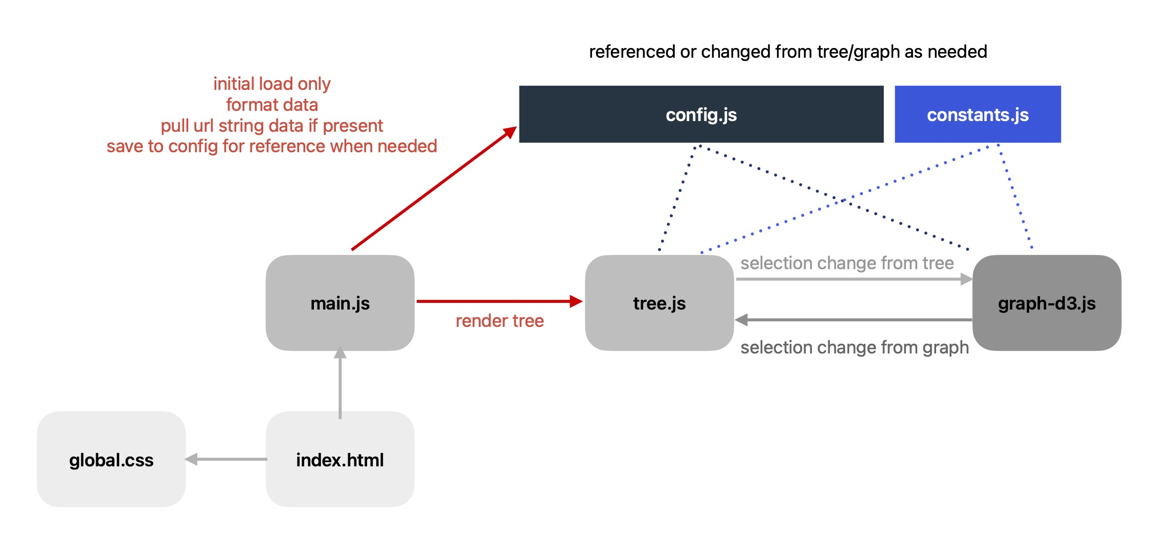
App Interaction Diagram

page | Notes
Index.html | Home page.  - Added some new features (loading animation, zoom buttons, tooltip headers, parameter menu, NN items, SP items, helpInfo tab)  - Kept some originals - view, app, hide/showInfo
global.css | Moved all css from index.html here - notes in file
main.js | This file is used once on loading and contains all the data manipulation.  The API fetch and nodes/links generation has not been changed.  Data manipulation which used to be in the graph.js has been moved here as it’s only required once.  Data is then stored in the required format in config.js  Functions list  - dataNullValueCheck - checks to make sure SEGMENT_NAME + SUBMODULE_NAME exist in the data - console if they don’t  - generateParameterData - uses nodes + links to parse data into required format, set link direction and ensure duplicate links are included  - getHierarchy - uses nodeData to generate submodule -> segment -> parameter hierarchy, set config.subModules and return as d3.hierarchy()  - setHierarchyData - generates high level hierarchy data to allow linking between submodules/segments + parameters at all zoom levels in Quilt/Middle mode  - handleUrlInputs - returns if reloading, otherwise checks url search string and sets parameters to ‘re-render’ the graph in that state.  - Options as follows  - NND - nearly neighbour, default view - NND=~POP:1 (parameter:degree)  - NNV - nearly neighbour, NN view - NNV=~POP:2 (parameter:degree)  - SP - shortest path, - SP=~POP:~POPEDSECLOWR (start:end)  - QV/MV - specifies whether to show in Quilt or Middle view  - Search string has a list of the submodules or segments which are expanded + maximum one highlighted parameter separated by _  ~ = upper case parameter
constants.js | Constants used in tree + d3-graph:  LINK_COLOR - link and arrow colour  ARROW_SIZE - arrow size  COLOR_SCALE_RANGE - submodule colours  MESSAGES - when there is no match for SP + NN  TOOLTIP_KEYS - variables to show in tooltip (if they exist in data)  NODE_RADIUS_RANGE - range for circle radii  We can add anything else you like here which you want easily adjustable
config.js | This is the global store which is used by tree.js and graph-d3.js and allows all the features to work together seamlessly.  Default settings  - currentLayout - "default", "nearestNeighbour", "shortestPath"  - graphDataType - “submodule", "segment", “parameter"  NB “submodule” = Macro, “segment” = Meso, “parameter” = Variable  tier1 = submodule, tier2 = segment, tier3 = parameter  - initialLoadComplete - prevents unnecessary reloading  - nearestNeighbourOrigin + nearestNeighbourDegree - for NN  - shortestPathStart + shortestPathEnd - for SP  - showArrows + showSingleNodes - toggled with menu button  Graph data set on initial load in main.js  - allNodeNames - list of all  - expandedMacroMesoNodes - used in macro/meso mode to store expanded nodes  * hierarchyData - full hierarchy  * subModules - list of all  - parameterData - data for Main graph  Tree data set on initial load in tree.js  - expandedTreeData - stored for expandAll button  - collapsedTreeData - stored for collapseAll button  - currentTreeData - reflects nodes on Main  - tier1And2Mapper - referenced when collapsing/expanding tree  Other  - defaultNodePositions - Main, set after 1st load so simulation only runs once  - selectedNodeNames - Main, nodes currently visible in default view + on tree  - notDefaultSelectedNodeNames - similar - for NN + SP layout only  - notDefaultSelectedLinks - links - for NN + SP layout only  - tooltipRadio - current tooltip radio selection  - macroMesoUrlExtras - storing URL info for quilt/middle view  - nnUrlView - flag set if default view NNV URL request to trigger move to NN layout after loading
tree.js | VariableTree = initial load function which sets up functionality of various buttons/select boxes and draws the tree  Function List  - getGraphData - gets the correct graphData depending on graphDataType  - renderGraph - rendersGraph - on load/after graphDataType change  - getColorScale - data from config + constants  - remToPx - responsiveness - gets current px size  - getSelectedPath - returns empty, half checked or checked box depending  - drawTree - draw the tree hierarchy in the current state (called by VariableTree, from itself AND from graph-d3.js)  - saveSvgAsImage - as described  - VariableTree - renders the initial interactive menu tree, sets resize event listener and sets functionality on various page items  - downloadImage button  - graphDataType radio button  - collapseExpand button
graph-d3.js | Graph component  initialises various things - data, radius scale, tooltips, zoom functionality, simulation, graphology (for NN and SP - old functionality used as base)  Then runs the simulation if needed (stored after initial render for Main) and depending on user action calls various update functions  - resetMenuVisibility - after render and layout change  - getMacroMesoDepthMultiple - radius collide perimeter changes by tier for both graphDataTypes  - getNodeLabelDisplay/getNodeLabelDy/getNodeLabelSize - node visibility, size + position dependent on graphDataType, currentLayout + currentZoomLevel  - getZoomCalculations - zoomFit from performZoomAction  - performZoomAction - after render + zoom buttons  - resetDefaultNodes - reset’s based on saved positions  - activateTooltipToggle - called every time tooltip redrawn with toggle  - getUrlId - uses regedit to fetch the valid id from saved URL positions  - getNeighbours/getNearestNeighbourLinks/generateSymmetricNNArray/renderNNLevelLabels - used by positionNearestNeighbour  - positionNearestNeighbour - finds nearestNeighbour and if NN view, positions them  - positionShortestPath - finds and positions shortestPath (or no path message)  - clickNode - on node click AND after update if NN level 1 default search  - switchLayouts  - updatePositions - this function holds the core d3 functionality which sets up the data depending on user selections and applies the joins + visual encoding +url ‘redraw’ functionality  - centroid/forceCluster - simulation functions  - getTooltipTable - builds the tooltip table html  - updateTooltip - different views in different circumstances  - measureWidth - measures text width - standard function  - showTooltipExtra - small ‘info’ tooltip  - switchLayouts - switches between default, nearestNeighbour + shortestPath, only available in graphDataType = parameter  - updateButtons - sets functionality for remaining chart buttons - reset, help info,downloadImage (click in tree), hide single, layout, show arrows, nn degree slider, zoom buttons  - updateSearch - lots of old functionality here - responding to search input changes  - initGraphologyGraph - runs on load, used with shortestPath  - getSourceId/getTargetId - ensures correct id whether working on original link data or manipulated link data (after simulation)

More detailed comments can be found within each file

Appendix A: list of changes
Completion Date | Tasks Completed
26th March | * loading animation  * Altered simulation so always runs in ‘fixed’ mode  * Zooms to extent of highlighted nodes after every update  * Remove pointer-events from tooltip  * Filtering tooltip results so only entries with data appear  * Allowing nodes to be draggable in ALL layouts - fixing after
28th March | Filter Menu -look and feel  * default collapsed  * Colour coding  * Collapse/expand arrow  * Select box (all checked initially)  * add select/unselect functionality + up stream part selected  * Select all button  * Unselect all button  Highlighting  * add highlight/unhighlight functionality to graph  * Add click multi select  * Add visual encoding  Filter Menu -functionality  * hook up changes - highlight on graph - change on list  * Hook up changes - search box - highlight on graph - check on list  * Hook up changes - change on list - highlight on graph  Tooltip functionality  * hover always shows single (how do we distinguish if a node is clicked)  * Fix on click  * Table if multiple (scrollable)  * Show tooltip after selection in search box and/or on list  * Position moves to right if necessary  Menu functionality  * Hook up show single nodes  * Hook up view/hide arrows button  Bugs  * Bug - node labels after highlighting  * Alter name label size so always the same  * handle overlapping arrows/general visibility - a bit better?  * Show menu - closed button - inconsistent - ?just switch text
1st April | Bugs/Small Fixes  * Collapse all - not maintaining state properly after a manual expand  * add visual encoding for node hover when selected  * Issue hovering over nodes which aren’t ‘visible’ triggering tooltips  * Centre loading animation on page  * After unselecting a node - restore to all visible if selected count === 0  * fuzzy searching - switch so startsWith come first, then fuzzy  * add button tooltips  * Tooltip table - content - sort by submodule?  * Tooltip table - hover over name - tooltip showing parameter explanation (if it exists)  * Tooltip table - needs to be less prominent/styled better  * Tooltip table - Add trash icon - doesn’t do anything yet, what do you think?  * SP search boxes - z index issues  * NN - stack circles nicely if space  * NN - add extra simulations if needed  * NN - make link lines look less pattern (0.4)  * NN - hierarchy errors at degree 3 - will be something to do with nodes going in  * NN/SP - toggling back to default if hide icon menu clicked  * Issue with data - again have added a temp fix, discuss next week
4th April | *Switch to d3 from pixie  - added a toggle at the top for Middle + Quilt view  - Added initial functionality for Middle + Quilt view  * NN and SP - using selected nodes to start + adding results to default after a switch  * Table Tooltip - now a bit larger font/padding - don’t want to go too big as we need the space, tooltip aligns top left - better?  - other bugs I fixed as I found them
10th April | - By default showArrows = true  - Arrows are always shown in Nearest Neighbour, Shortest Path, Segment View, SubModule View  - Shift + click on any node in default view goes direct to Nearest Neighbour  - Whenever any nodes are selected the option on the menu is now “select All”  - Zooming - should now be working properly in all cases (including Shortest Path)  - Shortest path - labels always visible  - Nearest Neighbour  - Removed labels apart from the root  - Added titles to show roots, drivers + outcomes  - Fixed the error so it’s now only showing the connections in the nearest neighbour path (ie not show if a level 2 driver happens to have a link to a level 2 outcome)  - Mouseover any node to see connections -> root  - Mouseover any node to get a standard tooltip  - Info panel + icon  - Download icon button  - changed the labels from to Show/hide interactive menu - not sure that is the right words but work in progress!
14th April | 1. reworking app so that it is responsive to screen size and adjusts as you resize the window including the following  - all fonts and sizes are based on rem (partially set up in the original app) - see start of css in index.html  - * 4 levels based on screen width (< 668px, < 768px, < 1024px, >= 1024px)  - * minimum screen size of 480 x 480px  - * this allows the tooltip to stick top left, the panel to stick top right and the info panel to go above the zoom buttons. They will never overlap  - * the user can expand the panel to full height but the tooltip has a maximum height so there will always be screen space available to see the visualisation (albeit pretty tiny if your width is 480px!)  - * the info message (for Shortest Path if no matches or either Shortest Path/Nearest Neighbour if nothing selected yet) is always top middle so never overlapping anything  2. fix the zooming - should be 100% working in all scenarios, please try and break!  3. NN titles overlapping with nodes (fixed with zooming)  4. Node Label Visibility - new strategy  * normal behaviour - visible at zoom 200%, smaller  * default - if nodes are selected, only these have labels  * segment, submodule, shortest path, nearest neighbour (root node) - always visible  * shortest path + nearest neighbour (root node) - text twice the size  * NN + SP - added reset buttons  * NN + SP - table now also shows drivers and outcomes  * Hide Single Nodes button - bug fixed
17th April | - View order has changed + new labels - Quilt, Middle, Main  - Quilt appears by default  - Loading message now appears if needed  - when switching between Views  - when switching between Collapse All + Expand All  - when switching layouts  - when selecting nodes, segments or submodules from the list  - clicking a node in Main OR searching for a node in Main automatically does a NN 1st degree search (user welcome to switch to NN and see the different layout and/or up the degrees to 2 or 3 if they want)  - due to above change, when switching layouts back to default from NN + SP, you see ONLY results from previous SP or NN search - no longer adding to the list (You can still add to the list by selecting and deselecting from the dropdown menu)  - highlight NN or SP end/start - I’ve added a white stroke and a dash array to these nodes - what do you think? Easily tweaked..  - When in Main but showing NN or SP results a new toggle appears at the top of the tooltip - (both, in only, out only)  - Add Reset button to default when not expanded all
9th May | NN Source - highlighting - switched to a flashing animation so it should be visible from the highest node level + updated so the search-input box also includes this value (after a click and after a search)  NN Default - make names more legible - I’ve changed the zoom to 95% from 90% and made the labels bigger if in default, parameter, NN. It zooms in to the # of visible nodes (ie the NN) - zooming further might mean the user doesn’t spot some neighbours…  NN Node labels - This is a compromise between overlap and space. I’ve put the names back in at the ‘normal’ size. On nodes like POP there is overlap but you can always drag them around to see and position yourself?  NN Slider - 1,2 and 3 always visible  Quilt, Middle - click to hold the mouseover  Reset button - bugs appearing/not appearing at the right time - fixed  Bug - node labels after a reset - fixed  Bug - arrow visibility on Main/Quilt after a main - fixed  Bug - dragging - fixed  Tooltip - added Display Name (data missing for lots) to table + single view  Tooltip - added NN header
14th May | SP - clear ‘end’ search box (unless coming from the tooltip table - see 3)  SP - add an icon button to the tooltip table when in NN mode which automatically goes to the SP between NN node + selected row
19th May | * Documentation - writing up functionality, changes over the course of the project + fulfilment of original requirements  New Functionality in Quilt and Middle view to  - click on a submodule and expand to see segments inside  - Click on a segment and expand to see parameters inside  - Click an expanded submodule/segment to collapse all within that group
28th May | New Quilt Middle expand/collapse functionality  To expand - press click  To collapse:  * segment - hold down either shift or ctrl or alt or command and click (I can add right click too if you like)  * parameter - just click (but it will also work if you hold keys above down)
3rd June | New functionality to ‘redraw’ charts using the URL - starting with NN  Adding a button to save the URL  Bug fix - hover on parameter Quilt  Writing some basic test scripts
6th June | Removing URL button, add to URL as you expand and collapse.  Move to SP and Quilt/Middle as well (some known issues)
11th June  (Completed 17th) | * Quilt + Middle with URL - this is now working with parameter so that they are in the right place - most of the time. It is less accurate with Middle for a technical reason I won’t go into but much better. The added bonus of this new approach is the URL string is much shorter.  * Quilt + Middle parameter click - now instead of collapsing (which you do with shift/alt/command click) it highlights the node + it’s links + shows the label.  * Quilt + Middle parameter with URL - it reverts to the clicked state  * Quilt + Middle tooltip - now showing the ’normal’ single tooltip in the top left hand corner instead of the tiny ones  * Quilt + Middle labels - not an exact science but I’ve added code to scale the labels up as you zoom in so they are more readable.  * NN + URL - there is now NND and NNV generated so you can go to Degree 1 in either view depending on which you copy the link from
9th July | - arrows 25% larger  - macro view - variable nodes further apart  - meso view - making them wider apart messes up the whole view so I’ve left it. Shrinking the stroke-width has helped.  * Macro + Meso view - changed fill back to colour fill and stroke as previous  * unselect all button now top right whenever the menu is visible in Variable view  * only -> position switched around so arrow THEN text  * NAME field - put the arrow in brackets BEFORE the name  * tooltip table arrow toggles -BUG - this now updates, not sure why I didn’t apply this originally  * shortest path label bug fixed  * colours - switched to the new ones - see 25th July
25 July | - changed arrow + link colour  - Tested out some alternative colour palettes  - Added and LINK_COLOUR, ARROW_SIZE to constants.js (alongside colour palette options) to constants so easily changeable  - Updated code and test script so no further reference to Quilt/Middle - now Macro/Meso  - NB Meso mode is not working brilliantly - you’ll get much better insights and links by starting in Macro and drilling down to the links you want. Examining the submodules, their containing segments and then variables is probably better done in another chart format as it’s super busy and it’s very hard for the algorithm to get the spacing right - it does work though - just not optimal.

Phase 7 - list

Status | Size | Original DU Request | Notes
✅ | Middle | 1. Clicking on the name of a variable in the table list sends you to the variable in the diagram | Click NN icon to re-run NN search for this name + hover to highlight row + node
✅ | Small | 2. Hiding single (orphaned) nodes is on by default
✅ | Middle | 3. Make arrows stand out more when a variable is clicked with either highlighting or blinking | I’ve made them white. The problem is that when there are lots of links coming from all angles it compromises the visibility of the label  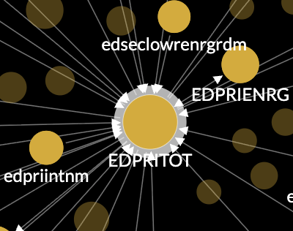  Only thought at this stage is maybe we don’t have arrows but have different encoding for the links (solid v dashed) but wouldn’t these have to change midway? Bit counter intuitive.
 | Large | 4. Fix the spacing issue when opening up from Macro to Meso or Meso to Variable.  We need the diagram to expand when clicking down to the variable level so that the names of the nodes are more visible.  Comment from our boss “When you drill down from the macro to the variable, what I would like is for the forced network diagram to "take the wheel". What that means is, if you open one meso level to the variable level with everything else at the macro level, the network diagram will reorganize to reflect the proximity and direct connections each variable has to other systems. Right now the variables stay in a geographically fixed space”. | The Meso + Macro level views were designed to be in a geographically fixed space. The core purpose here is to explore variables + their relationships.  The variable view can be ‘organised’ to reflect the proximity + direct connections each variable has to other systems BUT this only happens ONCE when the user opens to app - this has a huge impact on processing time as well as the overall user experience (jittering, nodes to different spots on the page etc).  If this functionality is a must we could have a popup/modal view? Once you’ve decided which nodes you want to explore (combination of variable, mesh, macro) you click a button and the re-organised view pops up in a new window? Probably less but 5 hours extra max.
✅ | Small | 5. Create size difference between nodes with more links | This was already there but now more pronounced. There is a constant NODE_RADIUS_RANGE  which you can adjust.
✅ | Medium | 6. Fix spatial issues. | Quite a wide scope!!! . I think this is covered by item 4 + 20 + 21
 |  | 7. Have shortest path display the structure of the diagram - Highlight within the diagram itself rather than take you to a new view.  Discussed this further and you want to keep the SP view but make it more obvious that you can toggle back to DEFAULT layout to see this in the diagram | Added a CTA in SP mode (also NN)  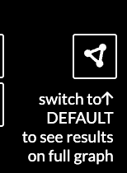  Also, default view tooltip has a header while results are valid  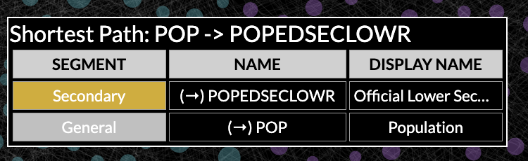
 |  | 8. Have an export table function for nearest neighbor with a full set of variables and their relationships | Icon appears only when NN search in play - 
Not now |  | 9. Represent bilateral variables - Sub-module in international relations, Show all 188 countries interactions | Waiting for new dataset
 |  | 10. Ability to copy and send a URL that will directly get you to the variable or Meso level of the diagram | ?MV=POP  ?QV=carprein
Not now |  | 11. A toggle button to keep or remove parameters from the display | Waiting for new dataset - difference between parameters and variables (UPPER + lower case) + additional complexity coming in.
✅ | Small | 12. Adding a method to view second and third connections to a variable other than adding add a 3 to the end of the URL https://ifsnetworkdiagram.du.edu/?NND=~GDS:3 | NN Degree slider now always visible whenever an NN search result is shown
✅ | Small | 13. Remove “Show hide arrows
✅ | Medium | 14. The Help window should be bigger and have Pardee's URL there. It also includes this text currently: Add your help information here. | New popup modal. Click outside panel or X to close. Content now in infoPanel.html so it’s easier for you to change/adapt
 | Bug | 15. When selecting a variable, the user is shown a menu with "in/out" toggles and related variables, including a link to the shortest path. Often, these related variables are directly connected. However, after selecting one, the interface can enter a loop or dead-end state, requiring the user to manually restart the entire exercise to proceed | I can’t replicate any more. It should be fixed. I’ve also added logic so the shortest path icon isn’t shown when the node is a direct link to the NN link (ie degree 1)  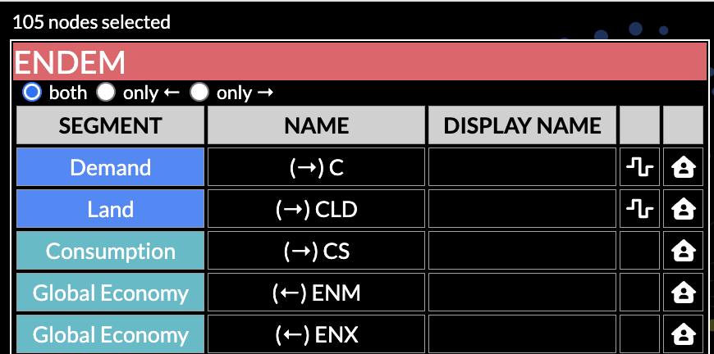
 | Bug | 16. Make sure that the UNSELECT BUTTON in the table is always visible. Sometimes its there and sometimes its not. | I think this is resolved - needs a thorough test. If someone comes across it again it would be helpful to have specifics as to when it wasn’t shown.
✅ | Bug | 17. When you hover over a variable in the tooltip that is too long to be fully shown, sometimes it shows you more information and sometimes it doesn’t. | Always shows the display name OR the parameter name if it’s missing. Parameter Definition is shown if it is there.
✅ | Small | 18. Can we get a close out option in the info box? I know you can close it from the main information table, but it is not intuitive.
 |  | 19. There seems to be a glitch when you expand down to variable level from macro or meso where the colors of the submodules don’t match what they should | 99% sure this is the data - there are some situations where segments + submodules don’t align. There is a console.error for every one.
✅ | Medium | 20. Fix the spacing in variable view so that you can see variable names | Is this enough - I can make them further apart if you like.
✅ | Medium | 21. Right now there is a lot of black space and I’m wondering if we spread the diagram out more horizontally that would help? | The initial draw fills the space as much as possible dependent on the screen dimensions. Re-size the positions hold. A refresh at any point will redraw.

Other changes that I’ve made as they came up.

- * added functionality so submodules are always roughly in the same area whatever the view (Macro, Meso, Variable) - better for the user to understand what’s going on and how they all relate to each other

- added a LINK_STRENGTH constant for demo purposes. This was 1, I’ve set it to 0.2 for now. It’s a trade off between reflecting "the proximity and direct connections each variable has to other systems” and overall symmetry/neatness of the visualisation and placement of the submodule groups. Some screenshots. This could be a user setting?

0 | 0.2 | 0.5 | 1
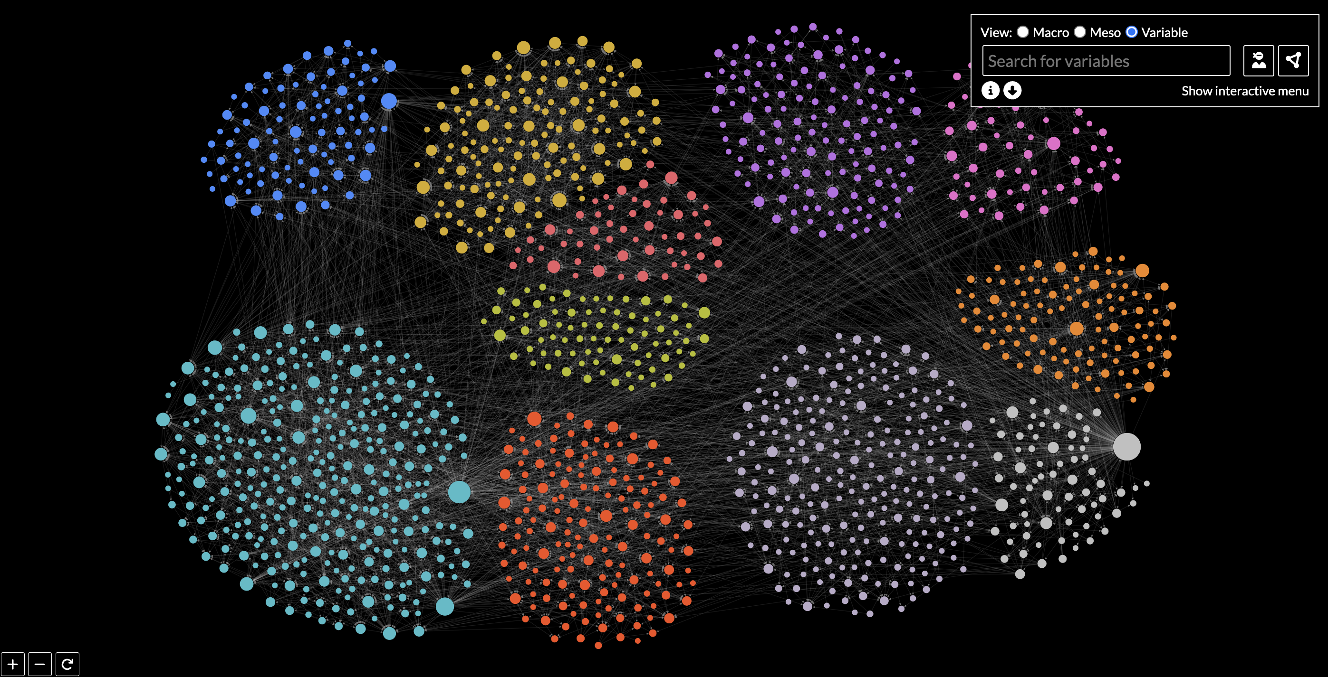 | 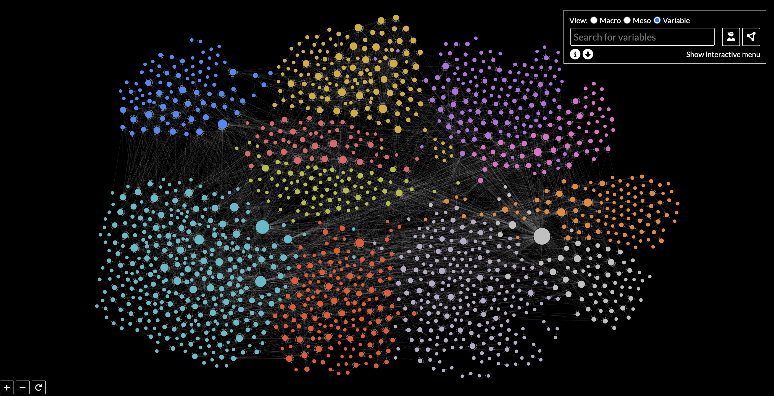 | 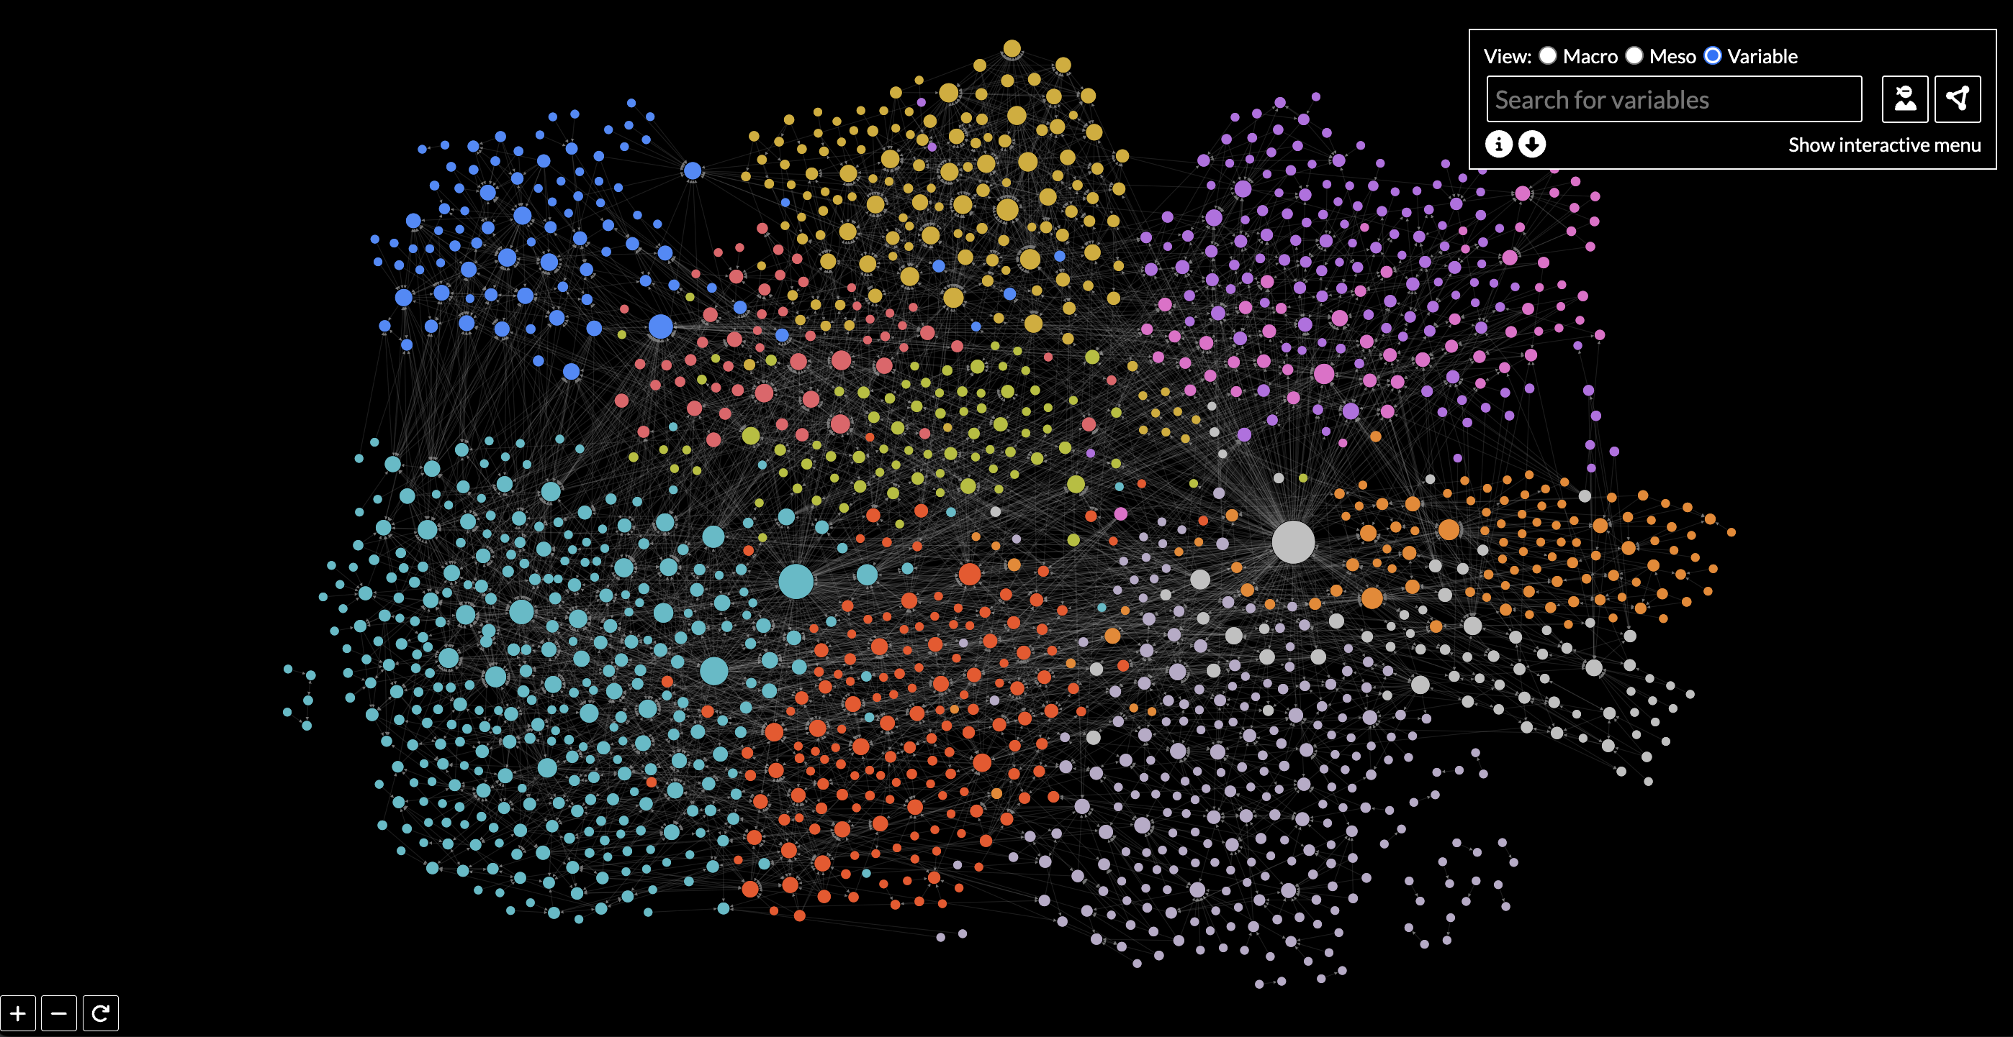 | 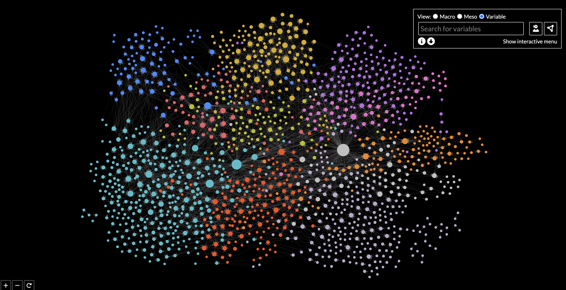

- added “Parameter Count” to Macro + Meso tooltips - maybe there is a better title?
- Moved tooltip position for nodes in the top left of the screen

Thoughts - do you want a more nuanced download system? Could remove superfluous stuff (ie menus, zoom buttons), add a title…

Phase 8 notes

1. Added some extra variables to the constants.js file and comments - please ping if anything need clarifying

Thanks Caleb for your suggestions. I haven’t added forceCluster and forceCollide as I think they will confuse things - if Bido/Julia can’t find a solution which Jonathan is happy with with what you’ve got (4 variables + radius range) then let’s discuss again. Will take me 5 mins so can do for free.

2. Created a Loom Video explaining the resizing and why it’s not possible to make it more dynamic

3. Shortest Path ‘Bug’ - is it a bug?

Steps:
* NN Search “POP”
* Toggle to 2nd Degree
* Click Shortest Path under AGLOSSPROD
* switch to Default

This is what I was expecting. It’s a shortest path search - there is no shortest path option as there is no NN or source node selected so there is nothing to map from + to. We could have a NN button which would then switch POP or GDPPCP or AGLOSSPROD back to NN (I’ve added it anyway, easy to remove). It behaves differently to an NN tooltip because it is showing different search results.

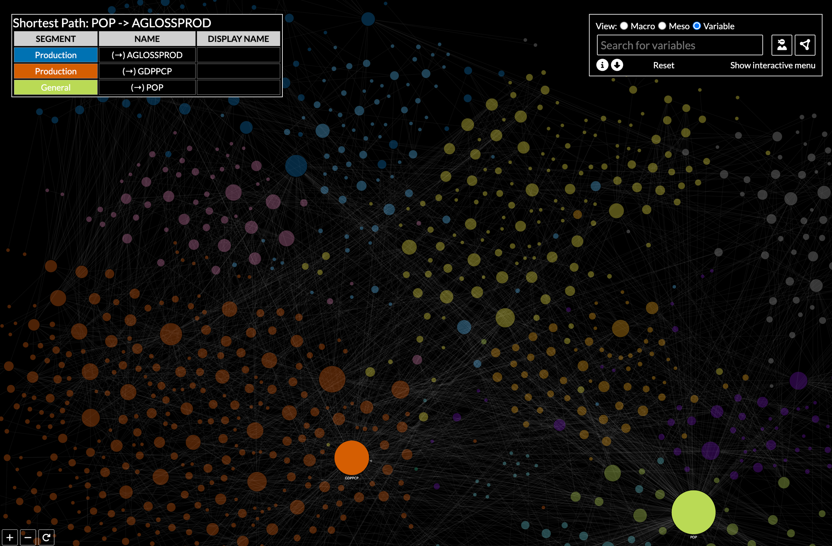

3. Moved download button to tooltip



4. Interactive Menu
Tick box staying in place (you’ll need to quiz Jonathan re: what he’s doing with zooming, the checkbox should ALWAYS be visible, I’ve made the width a bit smaller in case it’s his browser and the scroll bar?)
click variable name to activate NN (no indication to user that this is a feature but there is a slight opacity change on mouseover + a pointer - not optimal but hopefully users will work out what it does)

4. Bugs

* shortest path from tooltip - see above
* screen size svg size change - fixed + added a new feature so the zoom in fits to the active screen size
* table issues - fixed - I think, if you find it again, I’d be grateful if you could write down the steps which led there, happy to fix for free.
* realised in testing that single nodes were still showing on the interactive menu - removed
25th November 2025

* resolve bug when clicking outer area from settings menu
* comment out color from settings menu
* add label size to the settings menu (variable only)
* resolve meso/macro bug where links aren’t coming with nodes on drag
* meso/macro layout
* revert back to previous version where nodes were more bunched together
* change radius scale for all nodes so = # of links not # of parameters
* change text scale to reflect radius scale
* toggle parameters on/off - data coming

Loom 2nd December - https://www.loom.com/share/b372cb3ea7c74e43b69be38591dd3f11

14th December 2025 (discussed on 4th, waiting for dataset)

- Load new dataset and check for any bugs/issues across all views/functionality
- Add parameter yes/no toggle. (Default = no)
- Check if there are still 2 x ICT nodes and that we are checking for leading/trailing spaces
- Bug - see if I can track down bug where you click another node and it stalls as demo’d in your current version
- Bug - links disappear when going back from variable or meso to macro
- Add variable -> variable links to macro + meso view
- Change linkCount formula - SquareRoot ((backward links + 1) * (forward links + 1))
- If a variable is selected in macro/meso mode - keep that selection and view as NN when switching to variable mode

Phase 9?…. Deliverables 29th Jan

Loading speed/optimization:

* new process for converting data every time it changes - load time now almost instant, the process is super easy - sure won’t be a problem for Caleb
* variable view load time is still long initially BUT as long as you don’t refresh the page it is much faster after the initial load as positions are stored
* identified various points where node + link appearance can be changed without a reload (expand/collapse list change, NN search)

Sizing of nodes + overlap/layout of nodes
* this is crucial to pin down the formula and the radius range so we can move on to optimising the simulation settings. Otherwise we just go round in circles. I've made a new playground to help you make this decision - https://observablehq.com/d/b2db7b7808d17ded
* regarding overlap/layout - after several discussions I have a clear idea of what you’re aiming for. Once you’ve pinned down the above I can get this working for you.

Bugs + changes mentioned in Julia’s email (resolved):
- Changing the macro/meso tooltip connections word to Node count - this will show the number of nodes in that submodule
- In nearest neighbor view we are removing incidental links and arrows and only showing the arrow connections that go directly to the root node to reduce clutter
- Working on resorting the search bar so that it is more specific rather than alphabetical
- Adding display name to the tooltip (if there)
- Labels won't show when zoomed out so that the view is cleaner. They will appear when a node is clicked or it is zoomed in close enough. Labels will always be available when hovering
- Parameters will always be lowercase
- Macro/meso tooltip will always show Node Count (this currently disappears after you expand the node and then collapse it back)
- Macro/meso tooltip - submodule + segment name will be named correclty
- Variable view nearest neighbor labels appearing when you switch degrees
- When you toggle inputs only and outputs only in the tooltip, the arrows are still highlighted for the side that you don't want (will be fixed so that the only things highlighted are what you selected in tooltip)
- Parameters will not factor to node size and will always be the smallest
- Tooltip will appear when Show Parameters is clicked
- Clicking the variable name in the interactive menu will select the node in the diagram for you

Bugs found in testing

* macro + meso - node size = # of variables (not counting parameters any more)
* weird economy -> economy (and others) links now gone
* show/hide single nodes button commented out
adding display name to the search options seems to have made a difference - let me know
* shift click in meso mode (segment -> submodule)
* MM - if you’ve got a clicked node and then you expand, there is no longer a highlight (or value in search box)
* MM - move to macro or meso (opposite) when node selected - doesn’t reset properly, links not highlighting…
* Move to variable when node selected - still not quite right - test on initial and after other searches
Reset button disappears when you do an NN search (only sometimes - initial load???)
NN default search - hide interactive panel - background rect too short
Reset button needs to stop NN flashing
Need to redraw the links after reset
Need to clear search input after reset
Parameters - need to filter out of search results
Parameters - check reset button is working properly when showParameters is clicked

27th Feb
- ‘no submodule force’ video
- New force layout with areas for submodules and space in the middle for important nodes to be pulled to
- New sizing for macro/meso mode (3 hierarchy tiers)

2nd March
- fix overlap appearing on variable view
- make variable/parameter nodes in Macro/meso bigger
- Full test and code clean up after changes
Appendix B: Original List on Upwork + notes

Task | Notes re: resolution
Draggable Nodes - Nearest Neighbors: When the  central node is reselected and dragged, switch  modes so that clicking on other nodes does not  switch them to the central node and instead allows  them to be moved as well. The existing cancel  button can be used to exit both the dragging mode  and the Nearest Neighbors view.  Draggable Nodes  - Shortest Path: Likely needs enabled without  requiring a specific context-based check like with  Nearest Neighbors.  Draggable Nodes - Ensure that the selected node’s  position continues to update dynamically as they are  dragged, and that the links between nodes are  continuously redrawn in real-time to maintain  connections.  Once the drag is completed, the node’s position  should remain fixed - as it does under the current  usage - while the rest of the network continues to  respect the original now static force simulation  results. | Drag functionality works as required  * drags current node  * Drags links connected to current node  * Everything else remains fixed  - Position saved when done  - A tiny bit laggy when a node has loads of links (ie POP) but now we have d3 it doesn’t lose the link and doesn’t cause any errors  Drag functionality consistent across layouts.  (Will be when NN + SP complete)
Distinguish In-Flows & Out-Flows in Nearest  Neighbors & Shortest Path:  Create a toggle to show both drivers and outcomes,  just drivers, or just outcomes. This should help  clarify the clutter of too many arrows or unclear  relationships where the arrow is not visible due to  the offset of the variable name. | NN layout shows this AND the in/out flows are visible on the tooltip with the ability to filter
In cases where arrows overlap due to bidirectional  relationships, this must be fixed in a way that it no  longer overlaps, such as an offset. | Fixed
Shortest Path Ease of Use:  a. Simplify steps from the current process,  described here:  i. Find and remember ending node’s location  ii. Activate Show Shortest Path toggle in top-left  iii. Select starting node through either clicking on the  node or using the search bar  iv. Select ending node by clicking on the node  Shortest Path Ease of Use: b) At present, we cannot  use the search bar to select the ending node. At  minimum, we need this update to include enabling  this.  Shortest Path Ease of Use: Include an option to  clear the path selection or reset it by clicking an  empty space, as well as maintain a dedicated  cancel button.  Shortest Path Ease of Use: Improving the visibility  and design of the current cancel button would be  appreciated. | Shortest Path now has new layout which resolves all this and more.  Also, new feature on the tooltip after an NN search where you can choose a row from the table and click the shortest Path icon to trigger it
Static Force Diagram:  a. We need the network force to be disabled and the  nodes to hold static positions once the diagram has  been fully loaded. Given varying load times, this  should likely be based on the iteration count. | Done
Zoom In/Out Scale  i. We need a way for users with trackpads to be able  to zoom in/out. Currently if you zoom in it zooms the  webpage in – not the diagram. Creating a sliding  scale or another variation that would allow you to  control the zoom of the diagram is needed. | Solved before I started!
Fixed Pop-Up Description Box  i. Currently the description box for each variable is  only visible when you are hovering over the variable.  If the variable is clicked on, the box should stay so  that the variable name can be copied and links can  be provided in the description box.  1. Clicking the variable again should get rid of the  box  2. If no variable is selected then the hover feature  should remain | Done, much more functionality as well
Create Search Function for List View  i. The list needs a way to search for a variable | Decided not to do? Could be done if you like (pretty quick) but I think all the other functionality means it might not be needed..
Searching for Variables  i. The search for variables currently has to be exact.  We would like to change this so that you can search  for key words and widen the search so that  misspelled terms will show the closest examples | Done
Bug Fixes - Address an issue where upon reset,  ‘Show directions’ and ‘Show neighbors’ are active  despite not being highlighted. We would like it to be  highlighted whenever active.  Bug Fixes - Upon reset, there is a period where  “Hide Single Nodes” is not usable. Please identify  and address the source of the delay  Bug Fixes - In prior versions, dynamic scaling of the  UI elements was causing issues, and a more static  version was implemented as a workaround. This  causes occasional issues where either (1) parts of  the UI are cut off or (2) black bars can appear at the  bottom of the screen on higher resolution monitors  or in full-screen mode. Please revisit these and  related areas to address both issues. | Either not relevant as it works in a different way or fixed (UI responsiveness)

Appendix C - Simple Test Script

Last checked by Bryony Miles - 17th June 2025

 |  | Ok?
Initial Load | Macro view default  Submodules + links visible + draggable  2 buttons - info (show/hide info), download (downloads screenshot) + help tooltip  Zoom buttons - in, out, reset + help tooltip
Macro + Meso
hover | Highlights nodes, links and linked nodes, normal tooltip and expand/collapse helper tooltip
click | Drills down in submodule/segment - hovering still works as expected  Highlights (or unhighlights) if parameter (and shows links if they exist)  Using POPRETIRED as an example, search from initial state and then click down into submodules + segments, parameter -> parameter links should appear as expected
Shift/command/alt + click | Collapses -> segment if parameter, -> submodule if segment
Search box | Search for a node - if you select one it is highlighted
Show Parameters | Default is off. Clicking on then parameters should become visible..
MAIN
Initial Load | Main view selected  All nodes and links visible (after loading - which has animation) + draggable  2 buttons - info (show/hide info), download (downloads screenshot)  Zoom buttons - in, out, reset  Input Search box (Search for variables message)  Layout drop down (default selected) + help tooltip  Hide/Show interactive menu button (automatically show if small screen)  Interactive menu (can expand collapse as needed, all nodes selected, constantly in sync with nodes on the graph)
Search input | Doesn’t exist - nothing happens  Exists - drop down appears, select from choices (fuzzy searching)  On Select - chosen node flashing, nearest neighbours + links shown, labels for NN node only shown, tooltip appears with NN HEADER + SP links, reset button appears  Zoom in to see labels  After initial load - yes  After NN - yes (if nn node selected + degree === 1 it maintains state)  After SP - yes  After interactive menu - yes, removes all previously selected nodes and reverts to NN status as above On Select  After switching to Macro and back  After switching to Meso and back  After showParameters switch
Choose NN | Search input text “Search for origin node”  New slider with options 1,2,3 + circle reset button  Info + download buttons still there  Search for nodes to find the Nearest Neighbour message appears  Perform a search  Nodes appear, labels visible, url changes  Hover shows links and linked nodes + single tooltip  Degree slider ups the levels (or downs)  Reset clears the search input  Move to SP with input populated - top input same  Move to Default with input populated and degree = 1 - all results shown and NN default behaviour  Move to Default with input populated and degree > 1 - reset to nothing selected  After initial load - yes  From default where a node is chosen in NN mode (node populates search box)  From default where there is a random selection - search box cleared  From SP (no selection, or both selection) - search box cleared  After switching to Macro and back  After switching to Meso and back
Choose SP | Search input text “Search for start node”  New input “Search for end node” + reset button  Info + download buttons still there  Search for nodes to find the Shortest Path message appears  Search boxes work as normal  Once you have a valid start and end node  - no link - message appears at the top - There is no shortest path between the selected nodes  - Link - nodes appear  Reset - clears boxes  When you have a path of nodes  * nodes appear, labels visible  - reset clears the search box  - Hover node outline and individual tooltips  After initial load - yes  NN - yes (NN node in 1st box)  search - yes (NN node in 1st box)  interactive menu - yes, boxes cleared  After switching to Macro and back  After switching to Meso and back
Select/unselect from interactive menu | Unselected nodes have low opacity  Tooltip appears with a list of all selected and NO HEADER or SP links  After initial load - yes  search - (yes, adds to current selection, turns off NN, clears search input)  After NN - yes  After SP - yes  After switching to Macro and back  After switching to Meso and back  Click on node in menu for NN
Node mouseover | White border, single node tooltip  Expanded all - yes  Interactive menu - yes  Switch to Macro and back - yes  After SP - yes  After NN - yes
Node click | 1st degree NN search - reset and url link button appear
URL search | NN - default - NND=~GDPPCP:1  NN - degree 1 from NN layout - NNV=~GDPPCP:1  NN - degree 2/3 from NN layout - NNV=~GDPPCP:3  SP - ?SP=~GDPPCP:~GDPADJ  QV - various expanded (make your own)  Yes  http://localhost:5173/duForce/?QV=submodule-5__  http://localhost:5173/duForce/?QV=submodule-5_submodule-6_  http://localhost:5173/duForce/?QV=submodule-5_submodule-2_segment-21_~GDPPC_  http://localhost:5173/duForce/?NND=~HLCOSTMORB(MentalHealth):1  No  http://localhost:5173/duForce/?NNV=~GDPPCP:1  http://localhost:5173/duForce/?SP=~GDPPCP:~GDPADJ  MESO - no urls
UnselectAll | Only visible if no NN and some selected? Works as expected
Tooltip | Single node - shows all data which is there from values in constants.js - currently 'NAME',"DISPLAY NAME", "Parameter Explanation", "SUBMODULE_NAME", "SEGMENT_NAME"  Multiple nodes selected (but not NN) - … fields, small tooltip on hover  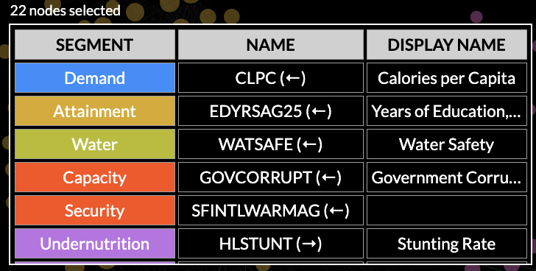  Multiple nodes selected (NN) - header with NN node and both/direction toggle. SP column - click to see shortest path.  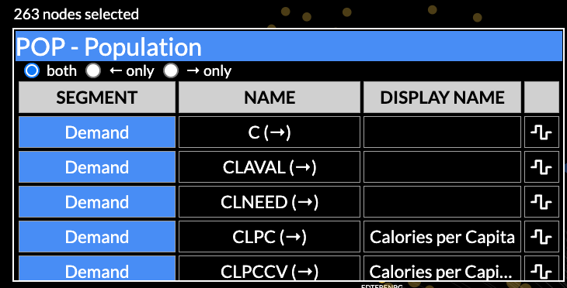  Mouseover (fields won’t show if no data)  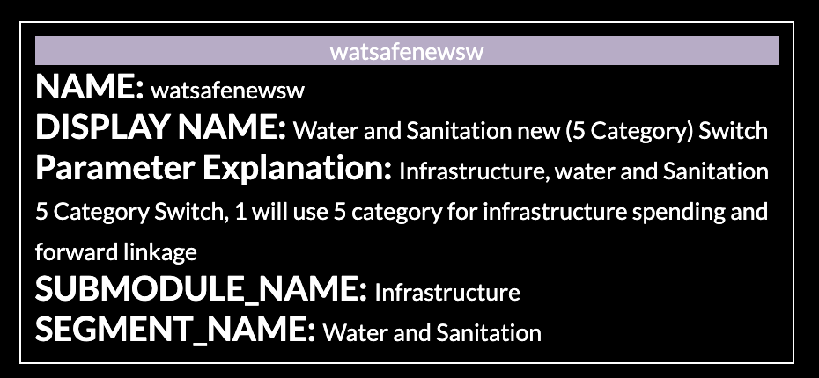
Reset button | Resets to initial state
Url link | NN search, SP search or Macro/Meso drill down - url is populated. Will open in this state in a new browser if copied, refresh clears it, limited functionality for re-viewing parameter nodes in Macro + Meso

